Sidwood Lichen Survey – preliminary list
Janet Simkin, 16th May 2004

Species List for site 02192/1 Sidwood riverside NY779889

69 Arthonia radiata
176 Baeomyces rufus
192 Bryoria fuscescens var. fuscescens
207 Buellia griseovirens
344 Chaenotheca ferruginea
375 Cladonia coniocraea
384 Cladonia fimbriata
396 Cladonia macilenta
408 Cladonia polydactyla var. polydactyla
416 Cladonia squamosa s.lat.
511 Evernia prunastri
521 Fuscidea lightfootii
532 Graphis elegans
533 Graphis scripta
582 Hypogymnia physodes
583 Hypogymnia tubulosa
592 Lecanactis abietina
639 Lecanora chlarotera
649 Lecanora expallens
672 Lecanora pulicaris
743 Lecidea lithophila
797 Lecidella elaeochroma f. elaeochroma
820 Lepraria incana s. lat.
998 Melanelia fuliginosa subsp. fuliginosa
997 Melanelia fuliginosa subsp. glabratula
921 Ochrolechia androgyna
938 Opegrapha atra
1015 Parmelia saxatilis
1022 Parmelia sulcata
1034 Parmeliopsis ambigua
1043 Peltigera hymenina
1056 Pertusaria albescens var. albescens
1058 Pertusaria amara f. amara
1079 Pertusaria leioplaca
1083 Pertusaria multipuncta
1087 Pertusaria pertusa
1110 Phlyctis argena
1145 Platismatia glauca
564 Porpidia crustulata
572 Porpidia tuberculosa
1192 Pseudevernia furfuracea s.lat.
1234 Ramalina farinacea
1266 Rhizocarpon reductum
630 Tephromela atra var. atra
1431 Trapelia coarctata
1595 Trapelia placodioides
1460 Usnea filipendula
1471 Usnea subfloridana
1640 Usnea wasmuthii
1510 Verrucaria nigrescens
1530 Xanthoria parietina

Species List for site 02192/3 Sidwood stell NY777887

176 Baeomyces rufus
371 Cladonia chlorophaea s.lat.
379 Cladonia crispata var. cetrariiformis
1749 Cladonia diversa
384 Cladonia fimbriata
386 Cladonia floerkeana
391 Cladonia glauca
396 Cladonia macilenta
416 Cladonia squamosa s.lat.
423 Cladonia sulphurina
515 Fuscidea cyathoides var. cyathoides
527 Fuscidea lygaea
578 Hypocenomyce scalaris
582 Hypogymnia physodes
649 Lecanora expallens
757 Lecanora orosthea
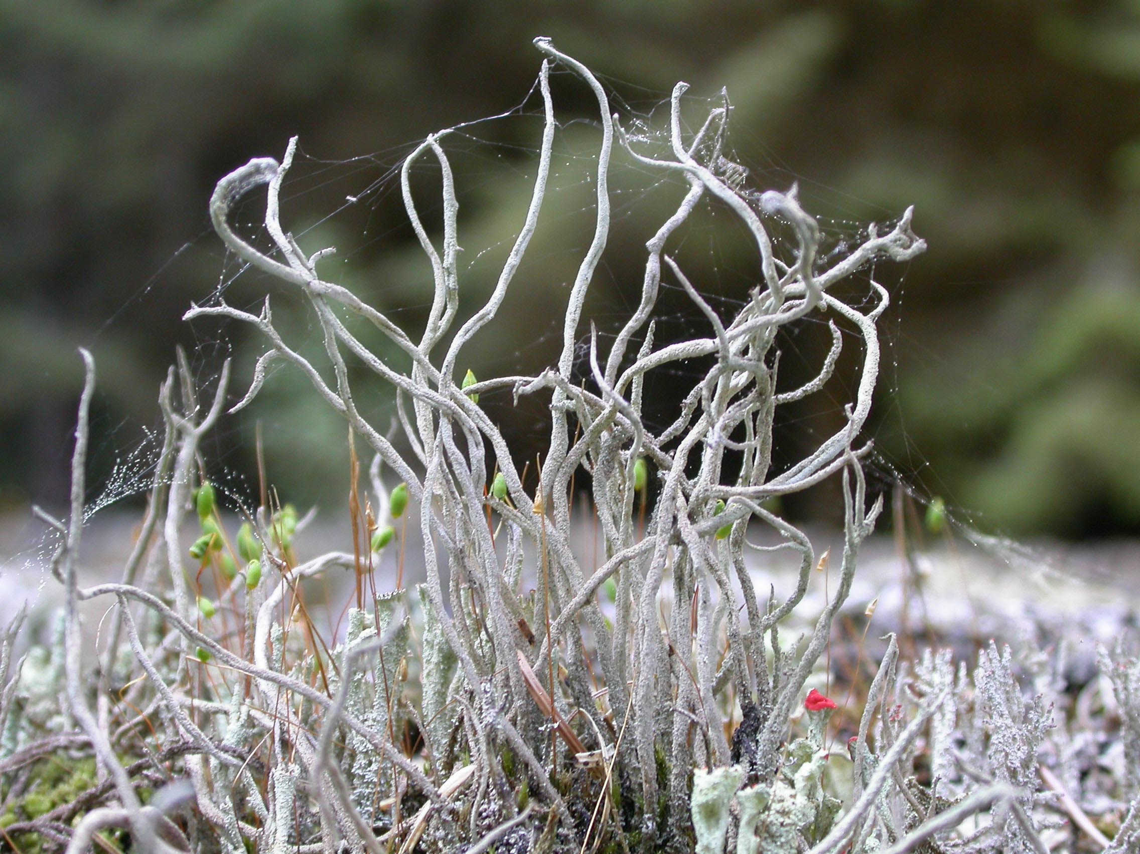
667 Lecanora polytropa
679 Lecanora soralifera
820 Lepraria incana s. lat.
1629 Lepraria lobificans
877 Micarea denigrata
880 Micarea lignaria var. lignaria
921 Ochrolechia androgyna
931 Omphalina ericetorum
1015 Parmelia saxatilis
1022 Parmelia sulcata
1066 Pertusaria corallina
1077 Pertusaria lactea
1145 Platismatia glauca
562 Porpidia cinereoatra
564 Porpidia crustulata
568 Porpidia macrocarpa
572 Porpidia tuberculosa
1200 Psilolechia lucida
1257 Rhizocarpon geographicum
654 Tephromela grumosa
1431 Trapelia coarctata
1595 Trapelia placodioides
692 Trapeliopsis flexuosa
1582 Trapeliopsis pseudogranulosa

(The numbers shown relate to the British Lichen Society Species List).

Cladonia glauca on the stell

